## Class: FeatureLayer

Function：创建图层实例

方法：1.setSelectionSymbol(symbol)

为当前的主要图层做标记

**require**([  
  "esri/layers/FeatureLayer", "esri/symbols/SimpleFillSymbol", "esri/Color", ...   
], **function**(FeatureLayer, SimpleFillSymbol, Color, ... ) {  
  **var** featureLayer = **new** FeatureLayer( ... );  
  **var** selectionSymbol = **new** SimpleFillSymbol().setColor(**new** Color([255,255,0,0.5]));  
  featureLayer.setSelectionSymbol(selectionSymbol);  
  ...  
});

属性：1. <String> objectIdField

表明每个图层都具有特点ID

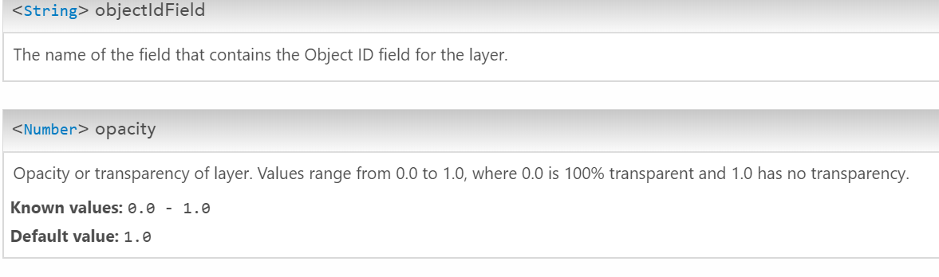

## Class: PictureMarkerSymbol

Function：在图层上画点

## Class: QueryTask

Function：在图层资源上执行一串查询操作

## Class: Query

Function：执行QueryTask中一连串的查询操作

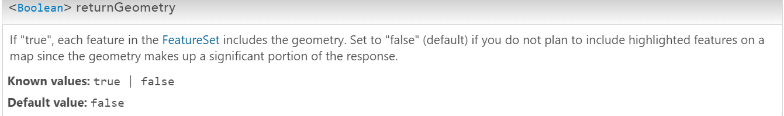

属性：1. <Boolean> returnGeometry

布尔型变量，若返回true，则FeatureSet中包含几何图形

若返回false，则不打算对几何图形中的重要信心做高亮显示

## Class: FeatureSet

Function：作为服务器返回的一串特征数据、或者输入任务。每个FeatureSet中都包含：几何图形、特征属性、标记和信息模板。如果FeatureSet中不包含几何图形，仅仅包含属性，那么FeatureSet就可以被当做行元素的表格。

## Class: FeatureTable

Creates an instance of the FeatureTable widget within the provided DOM node. The FeatureTable is a widget-based solution for where you explore and optionally edit the attribute data of a feature layer. The FeatureTable also integrates any additional information such as related records and attachments. Feature attributes displayed in the table can be edited by setting [FeatureTable's editable](https://developers.arcgis.com/javascript/3/jsapi/featuretable-amd.html" \l "editable) property to true. However, setting this property to true does not make the layer editable if the editing capability for the service is set to false on the server. The pieces of related information can be exposed as columns directly in the table by setting [FeatureTable's showRelatedRecords](https://developers.arcgis.com/javascript/3/jsapi/featuretable-amd.html" \l "showrelatedrecords) property to true. The attachments can also be displayed in the table by setting its [showAttachments](https://developers.arcgis.com/javascript/3/jsapi/featuretable-amd.html" \l "showattachments) property to true. To help distinguish the related records and attachments from the fields in the table, the related records and attachment columns are appended to the end of the table, with the column names shown in *italics*. Each record in the table shows the number of related records and attachments associated with it.

Function：

## [dojo/_base](http://dojotoolkit.org/reference-guide/1.8/dojo/index.html#id20)

This package and associated modules break out the functionality that formally was contained in the base dojo/dojo module. Many of the modules in this package define the “legacy” APIs for modules and packages that now sit in the root of the dojo package.

## Class: Draw

Toolbar支持通过绘画去创建新的几何图形，比如：点、线或者方形。若要去编辑这些已经存在的图形，就要使用Edit Toolbar

<!DOCTYPE html>

<html>

<head>

<meta http-equiv="Content-Type" content="text/html; charset=utf-8">

<meta name="viewport" content="initial-scale=1, maximum-scale=1,user-scalable=no">

<title>SimpleMarkerSymbol with SVG Path - Simplified</title>

<link rel="stylesheet" href="https://js.arcgis.com/3.21/dijit/themes/claro/claro.css">

<link rel="stylesheet" href="https://js.arcgis.com/3.21/dojox/widget/ColorPicker/ColorPicker.css">

<link rel="stylesheet" href="https://js.arcgis.com/3.21/esri/css/esri.css">

<style>

html, body, #map {

height:100%;

width:100%;

margin:0;

padding:0;

}

.dojoxColorPicker {

position: absolute;

top: 15px;

right: 15px;

-moz-box-shadow: 0 0 7px #888;

-webkit-box-shadow: 0 0 7px #888;

box-shadow: 0 0 7px #888;

}

</style>

<script src="https://js.arcgis.com/3.21/"></script>

<script>

var map;

require([

"esri/map", "esri/geometry/Point",

"esri/symbols/SimpleMarkerSymbol", "esri/graphic",

"dojo/_base/array", "dojo/dom-style", "dojox/widget/ColorPicker",

"dojo/domReady!", "esri/symbols/CartographicLineSymbol", esri/Color", "esri/toolbars/draw"

], function(

Map, Point,

SimpleMarkerSymbol, Graphic,

arrayUtils, domStyle, ColorPicker, CartographicLineSymbol, Color, Draw

) {

map = new Map("map",{

//basemap: "oceans",

//可供选择： "streets" , "satellite" , "hybrid", "topo", "gray", "dark-gray", "oceans", "national-geographic", "terrain", "osm", "dark-gray-vector", gray-vector", "streets-vector", "streets-night-vector", "streets-relief-vector", "streets-navigation-vector" and "topo-vector". Property added at v3.3. The "terrain" and "dark-gray" options added at v3.12. The "dark-gray-vector", "gray-vector", "streets-vector", "streets-night-vector", "streets-relief-vector", "streets-navigation-vector" and "topo-vector"

basemap: "satellite",

center: [ 20, 44 ],

zoom: 6,

minZoom: 2

});

map.on("load", mapLoaded);

function mapLoaded(){

//tb = new Draw(map);

//tb.on("draw-end", addGraphic);

//定义数组，给出具体点

var points = [[19.82,41.33],[16.37,48.21],[18.38,43.85],[23.32,42.7],[16,45.8],[19.08,47.5],[12.48,41.9],[21.17,42.67],[21.43,42],[19.26,42.44],[26.1,44.43],[12.45,43.93],[20.47,44.82],[17.12,48.15],[14.51,46.06],[12.45,41.9]];

var iconPath = "M24.0,2.199C11.9595,2.199,2.199,11.9595,2.199,24.0c0.0,12.0405,9.7605,21.801,21.801,21.801c12.0405,0.0,21.801-9.7605,21.801-21.801C45.801,11.9595,36.0405,2.199,24.0,2.199zM31.0935,11.0625c1.401,0.0,2.532,2.2245,2.532,4.968S32.4915,21.0,31.0935,21.0c-1.398,0.0-2.532-2.2245-2.532-4.968S29.697,11.0625,31.0935,11.0625zM16.656,11.0625c1.398,0.0,2.532,2.2245,2.532,4.968S18.0555,21.0,16.656,21.0s-2.532-2.2245-2.532-4.968S15.258,11.0625,16.656,11.0625zM24.0315,39.0c-4.3095,0.0-8.3445-2.6355-11.8185-7.2165c3.5955,2.346,7.5315,3.654,11.661,3.654c4.3845,0.0,8.5515-1.47,12.3225-4.101C32.649,36.198,28.485,39.0,24.0315,39.0z";

var initColor = "#ce641d";

//arrayUtils.forEach,colorPicker.setColor,colorPicker.on，类名.方法即可

arrayUtils.forEach(points, function(point) {

var graphic = new Graphic(new Point(point), createSymbol(iconPath, initColor));

map.graphics.add(graphic);

});

//取色模块，ColorPicker

var colorPicker = new ColorPicker({}, "picker1");//picker1为渲染方法div的id

colorPicker.setColor(initColor);

domStyle.set(colorPicker, "left", "500px");

colorPicker.on("change", function(){

var colorCode = this.hexCode.value;

map.graphics.graphics.forEach(function(graphic){

graphic.setSymbol(createSymbol(iconPath, colorCode));

});

});

}

//自定义变量lineSymbol画直线

var lineSymbol = new CartographicLineSymbol(

CartographicLineSymbol.STYLE_SOLID,

new Color([255,0,0]), 10,

CartographicLineSymbol.CAP_ROUND,

CartographicLineSymbol.JOIN_MITER, 5

);

//自定义方法createSymbol()，可重复调用

function createSymbol(path, color){

var markerSymbol = new esri.symbol.SimpleMarkerSymbol();

markerSymbol.setPath(path);

markerSymbol.setColor(new dojo.Color(color));

markerSymbol.setOutline(null);

return markerSymbol;

}

//调用连成直线的方法addGraphic()

function addGraphic(evt) {

//deactivate the toolbar and clear existing graphics

tb.deactivate();

map.enableMapNavigation();

// figure out which symbol to use

var symbol;

symbol = lineSymbol;

map.graphics.add(new Graphic(evt.geometry, symbol));

}

});

</script>

</head>

<body class="claro">

<div id="map"></div>

<div id="picker1"></div>

</body>

</html>

4.1.5 带地理参考的影像图层

在地图中显示本地带有地理参考的图像

使用原生Arc_Gis，根据不同的点在地图上做标记：  
